CO223 : LABORATORY SESSION 1

GAMAGE C.T.N.

E/13/107

GROUP 06

SEMESTER 3

29/01/2016

**A) Links**

Networking Cables are networking hardware used to connect one network device to other network devices or to connect two or more computers to share printer, scanner etc. Different types of network cables like Coaxial cable, Optical fiber cable, Twisted Pair cables are used depending on the network's topology, protocol and size.

Types of cables used in networks:

* Unshielded Twisted Pair (UTP) Cable
* Shielded Twisted Pair (STP) Cable
* Coaxial Cable
* Fiber Optic Cable
* Cable Installation Guides
* Wireless LANs
* Unshielded Twisted Pair (UTP) Cable

**Unshielded Twisted Pair (UTP)**

The cable has four pairs of wires inside the jacket. Each pair is twisted with a different number of twists per inch to help eliminate interference from adjacent pairs and other electrical devices. The tighter the twisting, the higher the supported transmission rate and the greater the cost per foot.

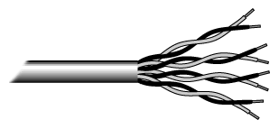

## Shielded Twisted Pair (STP) Cable

Although UTP cable is the least expensive cable, it may be susceptible to radio and electrical frequency interference (it should not be too close to electric motors, fluorescent lights, etc.). If you must place cable in environments with lots of potential interference, or if you must place cable in extremely sensitive environments that may be susceptible to the electrical current in the UTP, shielded twisted pair may be the solution. Shielded cables can also help to extend the maximum distance of the cables.

Shielded twisted pair cable is available in three different configurations:

1. Each pair of wires is individually shielded with foil.
2. There is a foil or braid shield inside the jacket covering all wires (as a group).
3. There is a shield around each individual pair, as well as around the entire group of wires (referred to as double shield twisted pair).

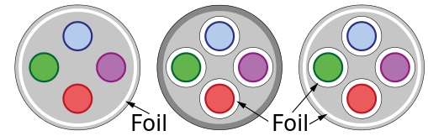

## Coaxial Cable

Coaxial cabling has a single copper conductor at its center. A plastic layer provides insulation between the center conductor and a braided metal shield . The metal shield helps to block any outside interference from fluorescent lights, motors, and other computers.

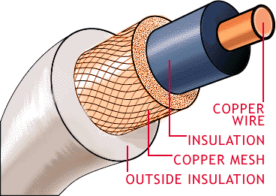

Although coaxial cabling is difficult to install, it is highly resistant to signal interference. In addition, it can support greater cable lengths between network devices than twisted pair cable.

## Fiber Optic Cable

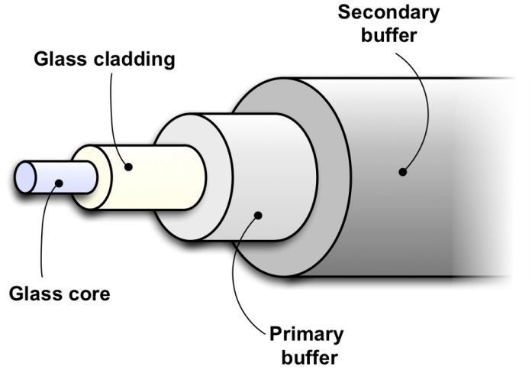

Fiber optic cabling consists of a center glass core surrounded by several layers of protective materials. It transmits light rather than electronic signals eliminating the problem of electrical interference. This makes it ideal for certain environments that contain a large amount of electrical interference. It has also made it the standard for connecting networks between buildings, due to its immunity to the effects of moisture and lighting.

Fiber optic cable has the ability to transmit signals over much longer distances than coaxial and twisted pair. It also has the capability to carry information at vastly greater speeds. This capacity broadens communication possibilities to include services such as video conferencing and interactive services. The cost of fiber optic cabling is comparable to copper cabling; however, it is more difficult to install and modify.

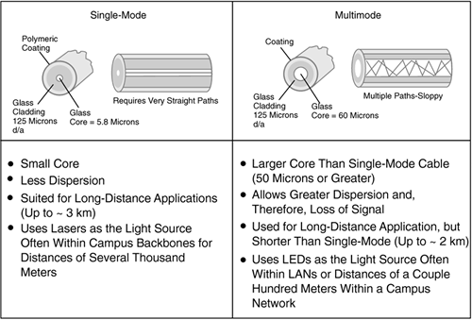 .

Fibers that carry more than one mode at a specific light wavelength are called multimode fibers. Some fibers have very small diameter core that they can carry only one mode which travels as a straight line at the center of the core. These fibers are single mode fibers.

**The RJ45 connector**

The RJ45S, a similar standard jack once specified for modem or data interfaces, uses a mechanically-keyed variation of the 8P8C body with an extra tab that prevents it from mating with other connectors.

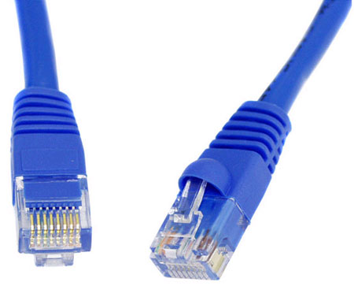

**CAT 5 connector**

Category 5 cable, commonly referred to as cat 5, is a [twisted pair](https://en.wikipedia.org/wiki/Twisted_pair) [cable](https://en.wikipedia.org/wiki/Copper_wire_and_cable) for carrying [signals](https://en.wikipedia.org/wiki/Signal_(electronics)). This type of [cable](https://en.wikipedia.org/wiki/Copper_wire_and_cable) is used in [structured cabling](https://en.wikipedia.org/wiki/Structured_cabling) for [computer networks](https://en.wikipedia.org/wiki/Computer_network) such as [Ethernet](https://en.wikipedia.org/wiki/Ethernet). The cable standard provides performance of up to 100 MHz and is suitable for [10BASE-T](https://en.wikipedia.org/wiki/10BASE-T), [100BASE-TX](https://en.wikipedia.org/wiki/100BASE-TX) (Fast Ethernet), and [1000BASE-T](https://en.wikipedia.org/wiki/1000BASE-T) (Gigabit Ethernet). Cat 5 is also used to carry other signals such as [telephony](https://en.wikipedia.org/wiki/Telephony) and [video](https://en.wikipedia.org/wiki/Video).

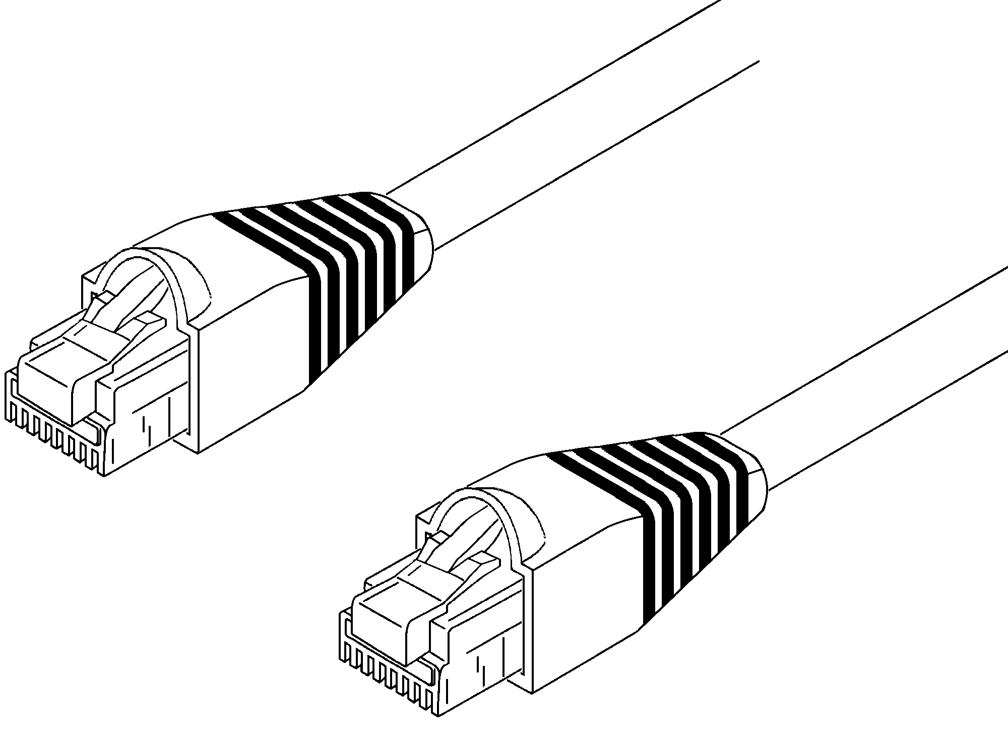

## Straight and Crossover cable

### Straight Cable

We usually use straight cable to connect different type of devices. This type of cable will be used most of the time and can be used to:

1) Connect a computer to a switch/hub's normal port.   
2) Connect a computer to a cable/DSL modem's LAN port.   
3) Connect a router's WAN port to a cable/DSL modem's LAN port.   
4) Connect a router's LAN port to a switch/hub's uplink port. (Normally used for expanding network)   
5) Connect 2 switches/hubs with one of the switch/hub using an uplink port and the other one using normal port.

### Crossover Cable

Sometimes you will use crossover cable, it's usually used to connect same type of devices. A crossover cable can be used to:

1) Connect 2 computers directly.   
2) Connect a router's LAN port to a switch/hub's normal port. (Normally used for expanding network)   
3) Connect 2 switches/hubs by using normal port in both switches/hubs.

## Medium Dependent Interface Crossover (MDIX)

A medium dependent interface crossover (MDIX) is a version of the medium dependent interface (MDI) enabling a connection between corresponding devices. An MDI port or uplink port is a port on a switch, router or network hub connecting to another switch or hub using a straight-through cable rather than an Ethernet crossover cable. Generally there are one to two ports on a switch or hub with an uplink switch, which can be used to alter between an MDI and MDIX interface.

Generally switches and hubs use an MDIX interface. Routers use an MDI interface in a workstation or PC environment. Newer technology for hubs, switches and routers automatically detect the appropriate cable connection type by the use of automatic medium-dependent interface crossover (Auto-MDIX) or Auto Uplink. With Auto-MDIX straight-through cable and Ethernet, crossover cable can be used. Switches and hubs not having Auto-MDIX will typically have one port that will not cross the line or crossover.

## Wireless Networks

A **wireless network** enables people to communicate and access applications and information without wires. This provides freedom of movement and the ability to extend applications to different parts of a building, city, or nearly anywhere in the world. Wireless networks allow people to interact with e-mail or browse the Internet from a location that they prefer.

**Wireless links**

* Terrestrial [microwave](https://en.wikipedia.org/wiki/Microwave)
* Communications [satellites](https://en.wikipedia.org/wiki/Satellite_of_Earth)
* Cellular and PCS systems use several radio communications technologies.
* Radio and [spread spectrum](https://en.wikipedia.org/wiki/Spread_spectrum) technologies.
* [Free-space optical communication](https://en.wikipedia.org/wiki/Free-space_optical_communication) uses visible or invisible light for communications.

**B) Systems/nodes**

**Network devices**

Computer networking devices are units that mediate data in a computer network and are also called network equipment. Units which are the last receiver or generate data are called hosts or data terminal equipment.

* **HUB**

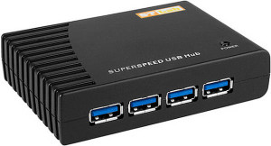

Hub is one of the basic icons of networking devices which works at physical layer and hence connect networking devices physically together. Hubs are fundamentally used in networks that use twisted pair cabling to connect devices. They are designed to transmit the packets to the other appended devices without altering any of the transmitted packets received. They act as pathways to direct electrical signals to travel along. They transmit the information regardless of the fact if data packet is destined for the device connected or not.

* **Switch**

A switch is an intelligent device that works in the data link layer. The term intelligent refers to the decision making capacity of the Switch. Since it works in the Data link layer, it has knowledge of the MAC addresses of the ports in the network.

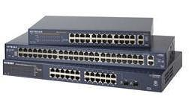

If data has to be sent from Computer A to Computer B, then, the data is transferred to the Computer B only, and not to any other computers connected on the network. Hence, it establishes a link between the sender and the receiver based on the MAC addresses. This also means that when data is being sent from A to B, Computer C can establish a link with Computer D and communication can take place between them. So, simultaneous data transfer is possible in a switch. Also, Hub divides bandwidth, but a Switch does not.It is also to be noted that a switch is a secure device, because it sends information only to the desired destinations, and also certain security features such as firewalls can be implemented in the Switches.

* **Router**

Any computer can be connected to the internet via MODEM, which performs the MODulation and the DEModulation operations. But, when there are more than one computer at home or in an organization, and you have a single internet connection, you need a Router. Router is a device which is used when multiple devices need to connect to the Internet using the same IP.

Any Internet Service Provider (ISP) provides a single IP, and especially for personal use, the IP address is assigned dynamically. This is done because, suppose, an ISP has 1000 IP addresses, it does not mean that it has 1000 customers. An ISP assumes that not all devices will be connected to the internet at the same time. Hence, when a user wants to access the internet, any IP address from the pool of IP addresses from the ISP will be assigned to connect the user to the internet.

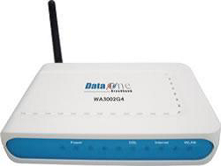

Hence, the router does the job of connecting multiple devices in a LAN to the internet using the same IP address. Since the router works in the Network Layer, it does forwarding on the basis of IP addresses.

## Modems

A modem is a device that makes it possible for computers to communicate over telephone lines. The word modem comes from Modulate and Demodulate. Because standard telephone lines use analog signals, and computers digital signals, a sending modem must modulate its digital signals into analog signals. The computers modem on the receiving end must then demodulate the analog signals into digital signals.

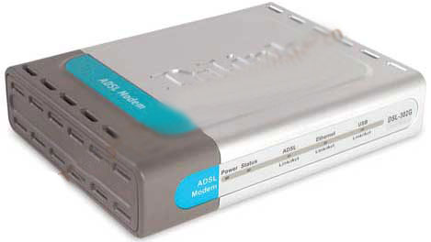

Modems can be external, connected to the computers serial port by an RS-232 cable or internal in one of the computers expansion slots. Modems connect to the phone line using standard telephone RJ-11 connectors.

# Ethernet Networking Interface

Ethernet Networking Interface, or ENI, allows any computer on Ethernet network to access controllers allowing users to send production data, alarm messages, or status information to computers, cellular phones, or pagers capable of receiving e-mail. The ENI module allows companies to leverage existing cable, hubs, switches, and routers already installed in facilities.

**Serial interface**

A data channel that transfers digital data in a serial fashion: one bit after the other over one wire or fiber. Serial interfaces may have multiple lines, but only one line is used for data. The other lines are used for control. On earlier PCs, the serial port was a serial interface for attaching modems and data acquisition terminals, and sometimes mice. See [serial port](http://www.pcmag.com/encyclopedia/term/51137/serial-port).

**WAN interface**

A wide area network (WAN) is a [telecommunications network](https://en.wikipedia.org/wiki/Telecommunications_network) or [computer network](https://en.wikipedia.org/wiki/Computer_network) that extends over a large geographical distance. Wide area networks are often established with leased telecommunication circuits.

## Console Port

The console port is configured as data terminal equipment (DTE). To connect a PC terminal to the console port, use the RJ-45-to-RJ-45 rollover cable, and either the RJ-45-to-DB-25 female DTE adapter or the RJ-45-to-DB-9 female DTE adapter (labeled "TERMINAL").

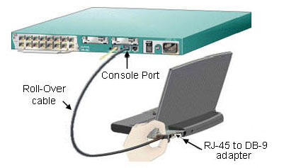

**C ) A Network**

A computer network is a set of connected computers. Computers on a network are called nodes. The connection between computers can be done via cabling, most commonly the Ethernet cable, or wirelessly through radio waves. Connected computers can share resources, like access to the Internet, printers, file servers, and others. A network is a multipurpose connection, which allows a single computer to do more.

Network topology is the arrangement of the various elements (links, nodes, etc.) of a computer network. Essentially, it is the topological structure of a network and may be depicted physically or logically.

The layout pattern of the interconnections between computers in a network is called network topology. You can think of topology as the virtual shape or structure of the network. Network topology is also referred to as 'network architecture.'

Devices on the network are referred to as 'nodes.' The most common nodes are computers and peripheral devices. Network topology is illustrated by showing these nodes and their connections using cables. There are a number of different types of network topologies, including point-to-point, bus, star, ring, mesh, tree and hybrid. Let's review these main types.

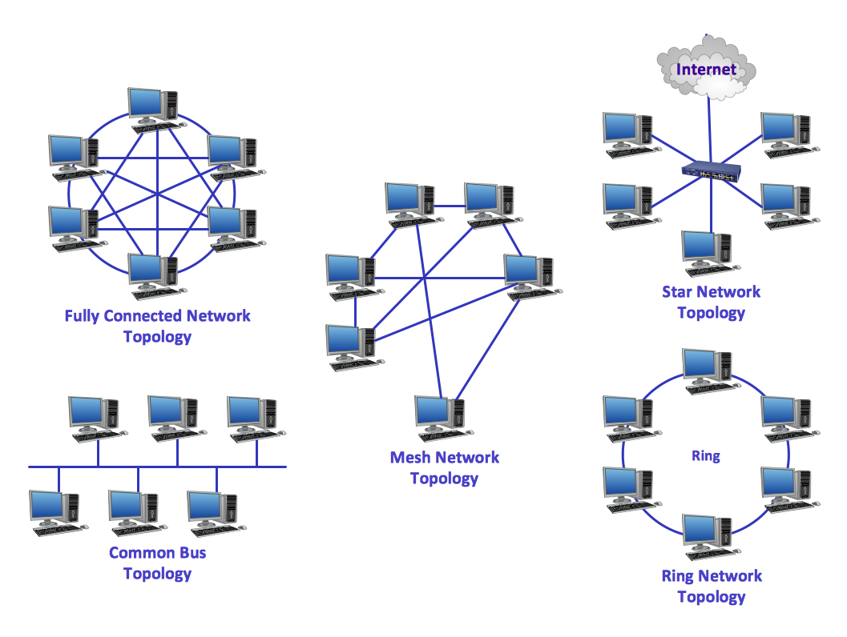

# LAN Topology diagramLAN topology diagram, wireless router, switch, server, scanner, router, radio waves, laptop computer, inkjet printer, iPhone 4, desktop PC, cloud, IP phone,

**D) Addresses to interfaces in the network**

**Network Addresses**

A network address serves as a unique identifier for a computer on a network. When set up correctly, computers can determine the addresses of other computers on the network and use these addresses to send messages to each other.

One of the best known forms of network addressing is the Internet Protocol (IP) address. IP addresses consist of four bytes (32 bits) that uniquely identify all computers on the public Internet.

Another popular form of address is the Media Access Control (MAC) address. MAC addresses are six bytes (48 bits) that manufacturers of network adapters burn into their products to uniquely identify them.

**How addresses have been assigned to network interfaces in the lab**

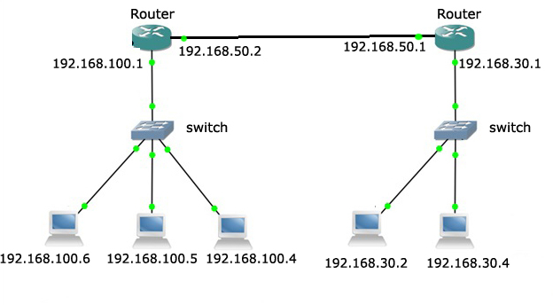

**E) The Department Network**

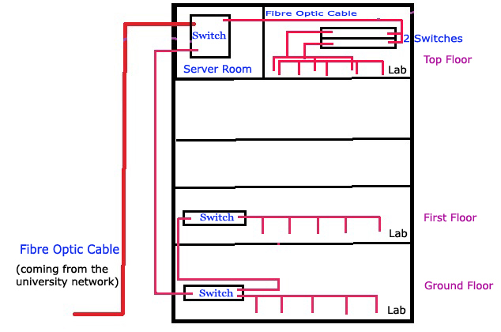

The computer engineering department receives a fiber optic network cable which belongs to the university’s network. It directly goes to the server room in CE 4th floor. From there the network is divided using a switch to send it to the ground floor and to the 2 switches placed in the CE top floor, those two switches divide the network for the top floor lab computers. The network connection received by the ground floor is again divided using a switch to send to the 2nd floor and to the lab computers in the ground floor. The short connections are linked using multi-mode fiber optics. In the first floor there is another switch which is used to divide the network to the computers in that floor. The network is further more extended using wireless Wi-Fi connections.

**F) The University Network**

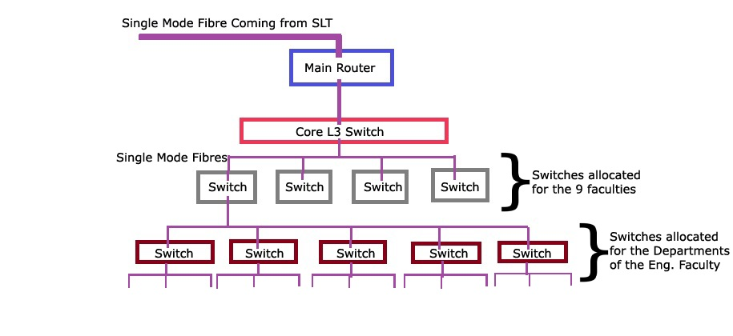

The University of Peradeniya’s network provides secure access to the Internet and administrative systems. Students, faculty, and staff can connect to the network while on campus or off campus.

While on campus, students, staff, and faculty can access the University network through the campus-wide network via one of the Ethernet jacks across campus. All users who wish to access the network must have an active University network account. The network blankets the campus with coverage and facilitates traditional and informal learning opportunities unconstrained by place and formal structure.

The connection coming from the SLT is directed to the Core L3 switch by the main router. The Core L3 Switch divides the network for the nine faculties. This main router and the switch are placed in the Engineering faculty. The connection is distributed to the nine faculties using the Single mode fiber optic cables. In each faculty another switch is installed to divide the connection for the various departments inside the faculty.

**Reference**

* http://study.com/academy/lesson/how-star-topology-connects-computer-networks-in-organizations.html
* http://compnetworking.about.com/od/basicnetworkingconcepts/g/bldef_address.htm
* http://www.cisco.com/c/en/us/support/docs/ip/routing-information-protocol-rip/13788-3.html
* https://en.wikipedia.org/wiki/Network_address
* http://www.howtogeek.com/99001/htg-explains-routers-and-switches/
* http://www.tutorialspoint.com/computer_fundamentals/computer_networking.htm
* http://www.webopedia.com/TERM/N/network.html
* https://wiki.archlinux.org/index.php/working_with_the_serial_console
* https://en.wikipedia.org/wiki/System_console